Before Reading – Preview

ANTICIPATION GUIDE 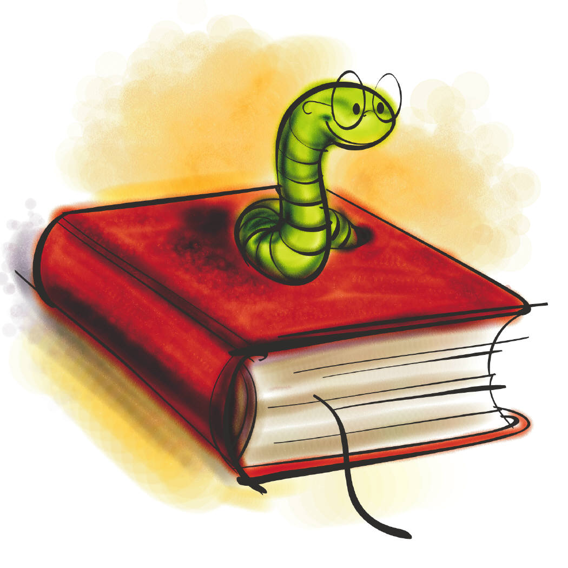
(adapted from Buehl, D. (2001). Classroom strategies for interactive learning and Alvermann, D.E., Phelps, S.F., & Ridgeway, V.G. (2007). Content area reading and Literacy.)

What? The anticipation guide asks students to consider statements
that preview the main ideas. Students may respond individually,
with a partner, or in a small group. The responses are then used
to promote discussion, generate questions, and make predictions.

Why? The anticipation guide helps students connect prior knowledge
to new information and creates a “hook” that invites students
into the reading.

How? Identify the major ideas and concepts that students will be
studying.

Write three to six statements that challenge or modify students’
existing understandings of the material. Include statements that
will generate some agreement between student responses and
information from the text. The statements that allow students to
demonstrate a partial understanding of the subject or statements
that reveal misconceptions often work best.

While studying the new information, students should mark areas
that connect to the anticipation guide.

Return to the statements on the guide after reading for discussion
and review.

Examples:

Language Arts – Before reading the play The Rising of the Moon

We are going to read a play called The Rising of the Moon. It is about a rebel on the run during the Irish Revolution. He tried his best to outsmart the police and avoid being captured. The play deals with many issues of basic human rights for all people.

Directions: Read the list of issues below. If you agree with a statement, make a check in Column A. Be ready to explain why you agree or disagree with each item.

A B
(You) (Author)
_____ _____ 1. It is always wrong to kill.
_____ _____ 2. A person should be willing to die for his or her country.
_____ _____ 3. People who live in the same country usually think alike.
_____ _____ 4. All men are brothers.
_____ _____ 5. Police are cold and unsympathetic.

Once we have discussed these items in class, read the play. If you think the author would agree with you, make a check in Column B. You must be able to cite evidence from the play to support your choices in Column B.

Math – The Order of Operations

Directions: We have already studied the four basic number operations. Now, we are going to examine expressions that involve two or more operations. Before reading about the “Order of Operations Agreement,” think about the mathematical expressions and their simplified values listed below. Based on the expression and its simplified value, predict a rule for the order in which mathematical operations are computed. Be able to explain your decisions.

Expression Simplified Value Predict Rule

1. 4 x 3 + 4 x 4 16
2. 10 – 3 x 5 28
3. 5 (3 + 2) 25
4. (5 – 2) 2 9
5. 8 + [13-5(6-4)] 11

Foreign Language: Before reading “A L’Hotel”
(Source: Beth Anne Connors, Royalton-Hartland Jr./Sr. High School, Middleport, NY.)

Part I: We are going to read a story about a man who is trying to make hotel reservations in France. Think about the types of things that people usually expect when staying in a hotel. Read each of the following statements and then mark the appropriate column stating whether you agree or disagree with each expectation. You must be able to explain your choices.

Agree Disagree
______ ______ 1. Unless it is vacations season, you will have no trouble
getting a room.
______ ______ 2. There will be a phone and a TV in the room.
______ ______ 3. There will be a bathroom in the room.
______ ______ 4. The hotel will have a pool and/or other recreational
facilities.
______ ______ 5. The hotel will be reasonably priced.

Part II: In Column A, list 5 words in English that will most likely appear in the text. Then read “A L’Hotel.” If you find any of the words you listed, write the French word in Column B. Write any other new words of phrases from the selection that you think are important at the bottom of the page.

A. Anglais B. Francais

1. _________________ __________________
2. _________________ __________________
3. _________________ __________________
4. _________________ __________________
5. _________________ __________________

Autres mot ou phrases importantes:

